OBJECTIVES ___Chapter 5: Section 5.6, The Law of Cosines (Pages 435 – 440).
- Know that an oblique triangle is a triangle that does not contain a right angle.
- Understand The Triangle Inequality Theorem: The sum of the lengths of any two sides of a triangle must be greater than the third side.
- Use the Law of Cosines to solve a right triangle or an oblique triangle when given SAS or SSS.
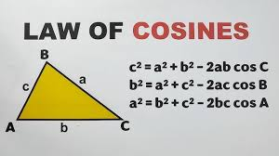
- Be able to find the areas of both right and oblique triangles.
- Use Area = 0.5(base)(height) for right triangles and oblique triangles when you know the base and the height.
- Use The Law of Sines Area Formula for oblique triangles when you know 2 sides and an included angle (SAS).
- Use Hero’s (Heron’s) Formula when you know all 3 sides (SSS).
- Use the Law of Sines when you know AAS, ASA, and SSA (the Ambiguous Case. (Pages 427 – 431)
- 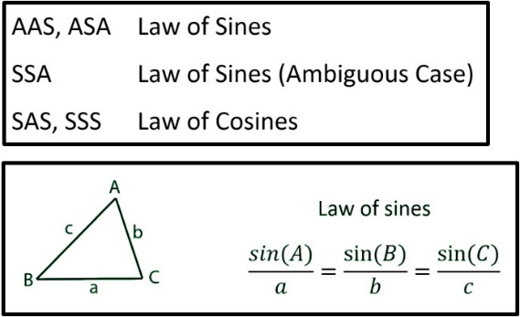
MONDAY (4.7.25)
Turn in your Saturday, April 5, E-Learning Work: E-Learning work: Illustrate each of these problems and show your work. Round to the nearest tenth. Pages 441 and 442, #29, 30, 35, 38. This work is due no later than Thursday, April 10.
Discuss this previously assigned work: Pages 432, 433, #37, 39, 43, 44.
Class Work/Homework: Review the Law of Sines for a test on Monday, April 14.
You may use one sheet of paper, 8.5 by 11 inches, front and back, when you take this test.

WEDNESDAY 4.9.25)
Discuss the previously assigned work: The Law of Sines Test Review
Homework: Study for The Law of Sines Test to be taken on Monday April 14. You may use one sheet of paper, 8.5 by 11 inches, front and back, when you take this test.

RIDAY (4.11.25) B-Day, No Class

